**Exterieur hond**

|  |  |
| --- | --- |
| **Naam:** | **Het houden van dieren**  **1.2 Raseigenschappen** |
| **Klas:** |
| **Datum:** |

Vul verder in

**Onderdelenkennis**

**Hond**

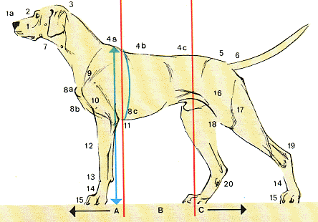

Vul de namen in

|  |  |  |  |
| --- | --- | --- | --- |
| 1a |  | 10 |  |
| 1 |  | 11 |  |
| 2 |  | 12 |  |
| 3 |  | 13 |  |
| 4a |  | 14 |  |
| 4b |  | 15 |  |
| 4c |  | 16 |  |
| 5 |  | 17 |  |
| 6 |  | 18 |  |
| 7 |  | 19 |  |
| 8a |  | 20 |  |
| 8b |  | A |  |
| 8c |  | B |  |
| 9 |  | C |  |